TU ID FIR Digital Filter
Benjamin A. Blouin
benjamin.blouin@temple.edu

Summary
This lab uses the PMOD DAC to create waveforms, and also creates a finite impulse response (FIR) digital filter on the PS. The FIR filter coefficients are derived from an arbitrary algorithm given for the lab. The filter is then dissected using Matlab to gain an idea of what the output of the filter would be with a sine wave input. The sine wave look-up table (LUT) is created on the PS, where it is then filtered through the programmatic FIR, and lastly output to the Waveform application interfacing through the EEboard. The conclusion of the lab is showing the outputs of the filtered and unfiltered sine waves.
Introduction
An FIR filter is simple in that if doesn’t require feedback, is inherently stable, and can be easily designed. An FIR filter of order N can be described by the following equations:
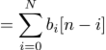
The filter’s effect on the sequence x[n] is described in the frequency domain by the convolution theorem:
and
and in the z-transform space:
The coefficients are derived by T.U. id LSD order; TU id. Values: 35622; derivations as follows:
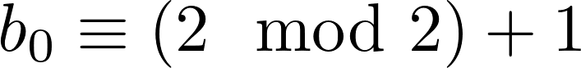
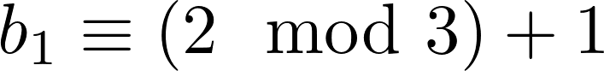
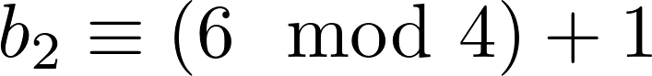
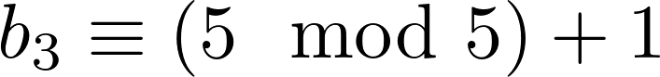
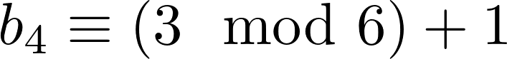
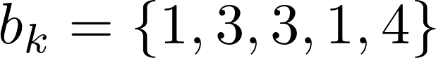, then the frequency response of the filter is:
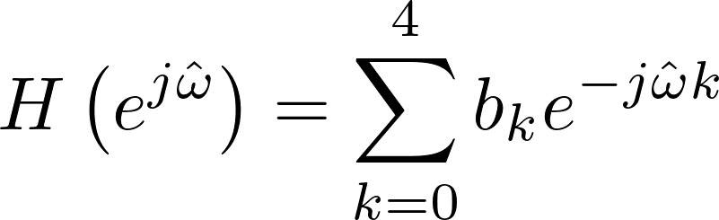

At n=1, the magnitude of H≈ 6, but Euler’s formula in reference to the sine wave construction is half, so we will say |H|≈12; This is borne out in figure 2. At n=0 the filter’s response is hard to characterize since it has four taps, needing four previous samples. The figure shows a magnitude of 20, but this is hard to show in real life. The filtered function, in the main.c code, had to be scaled by multiplying by ≈ 1/12.5, or 0.083. This scaled the filtered signal back down to the original signal.
Discussion
Using Vivado, SDK, Matlab, and Waveforms, this lab we easily accomplished. First the transfer function is created in Matlab, and it’s qualities can be determined, like magnitude response. Then a sine wave can be created and then filtered. Comparing the two is found in figure 15. We know that the decimal scale is from zero to 4096, and the upper 2000 and lower 2000 represent the y-value, we shift the sine wave along the y axis by 2000, and the amplitude is 2000. These are not exact values, but a good place to start. They are changed a little based on the sine wave typecasting truncation, as well as the physical measurements.
The Vivado block design is a simple PS+DA2, which includes a constraint file to manually map the DA2 to the correct output ports. The IP module is imported, and the ports are externalized; now a bitstream can be created. After opening the SDK, creating a new application, and copying the given main.c file, the board’s pmod can be connected to the EEboard. Running the main.c file creates a ramp output. The next step is to create a sine wave, which requires importing the math.h library, and we’ll be using stdint.h to have specific width integers as required by the lab instructions.
Conclusions

Appendices
Code
Main.c
// Lab 5 TU ID FIR Digital Filter
// Benjamin Blouin SP19
// Dr. Silage ECE3622

#include "DA2Pmod.h"
#include "xparameters.h"
#include "xil_io.h"
#include <stdio.h>
#include <math.h>
#include <stdint.h>
#include <limits.h>

//DAC2Pmod from Address Editor in Vivado
#define DA2acq 0x43C00000 //DA2 acquisition - output
#define DA2dav 0x43C00004 //DA2 data available - input
#define DA2dat1 0x43C00008 //DA2 channel 1 data - output
#define DA2dat2 0x43C0000C //DA2 channel 2 data - output
#define N_FIR 5

//FIR Filter Equation
//y(m) = b0 x(m) + b1 x(m-1) + b2 x(m-2) + b3 x(m-3) + b4 x(m-4)
static int LUTSIZE = 4095;

static inline void SineLUT(int16_t SINLUT[LUTSIZE]);
static inline void FIR_Filter(int16_t SINLUT[LUTSIZE], int16_t FIRaccum[LUTSIZE],int16_t STEPSIZE);

int main(void)
{
static int16_t STEPSIZE = 3; //Can change step size between FIR samples of Base Sine Wave

int16_t SINLUT[LUTSIZE]; //DAC SINE LUT ARRAY DEFINITION
int16_t FIRaccum[LUTSIZE]; //DAC SINE FIR LUT accumulator
SineLUT(SINLUT); //FILL DAC SINE LUT
FIR_Filter(SINLUT, FIRaccum, STEPSIZE);
int dacdata=0; //LUT index
int dacdav; //DAC data available
int dacacq=0; //DAC acquire

Xil_Out32(DA2acq,0);

while(1)
{
if(dacdata>=LUTSIZE)
dacdata=0;

dacdav=Xil_In32(DA2dav);
if(dacdav==0 && dacacq==0) //DAC not in use?
{
Xil_Out32(DA2dat1, SINLUT[dacdata]); //output DAC data
Xil_Out32(DA2dat2, FIRaccum[dacdata]); //output DAC data
Xil_Out32(DA2acq,1); //DAC acquire
dacacq=1;
}
if(dacdav==1 && dacacq==1) //DAC data available
{
Xil_Out32(DA2acq,0); //stop DAC acquire
dacacq=0;
dacdata = dacdata + STEPSIZE; //increment DAC data
}
}
}

void SineLUT(int16_t SINLUT[LUTSIZE]) {

for (int i = 0; i <= 4096; i++)
{
SINLUT[i] = (int16_t) 2046.9*sinf(2.0f * M_PI * ((float) i / LUTSIZE))+2049.9;
}
}

void FIR_Filter(int16_t SINLUT[LUTSIZE], int16_t FIRaccum[LUTSIZE], int16_t STEPSIZE){
//first four samples are special
//FIR Filter Equation
//y(m) = b0 x(m) + b1 x(m-1) + b2 x(m-2) + b3 x(m-3) + b4 x(m-4)

FIRaccum[0]=SINLUT[0];
FIRaccum[1]=SINLUT[1] + 3 * SINLUT[0];
FIRaccum[2]=SINLUT[2] + 3 * SINLUT[1] + 3 * SINLUT[0];
FIRaccum[3]=SINLUT[3] + 3 * SINLUT[2] + 3 * SINLUT[1] + 4 * SINLUT[0];
for(int i = 4; i<=4095;){
FIRaccum[i] = 0.0831*(SINLUT[i] + 3*SINLUT[i-1] + 3*SINLUT[i-2] + SINLUT[i-3] + 4*SINLUT[i-4]);
i+=STEPSIZE;
}
}
Filter_specs.m
%% FIR Digital Filter
% Filter Coefficients
den = 1;
num=[1 1 3 2 3];
Ts=2E-5;

% Original Sine Wave
t=linspace(0,1,4096);
x=2000*sin(2*pi*t)+2000;

% Transfer Function and Filtering System
H=tf(num,den);
sys = filt(num,den,Ts);

% Filtering the oringal sine wave

% Quick check if stable
isstable(sys)

%% Plotting Secion

figure(1)
options = bodeoptions;
options.FreqUnits = 'Hz';
bode(sys,options)
title('Bode Plot');

figure(2)
pzplot(sys)
figure(3)
freqz(num,den,4097)

y = filter(num,den,x);

figure(4)
plot(t,x)
yyaxis left
ylim([-2000 49000]);
hold on
plot(t,y)
yyaxis right
ylim([-2000 0]);
legend('Input Data','Filtered Data')
hold off
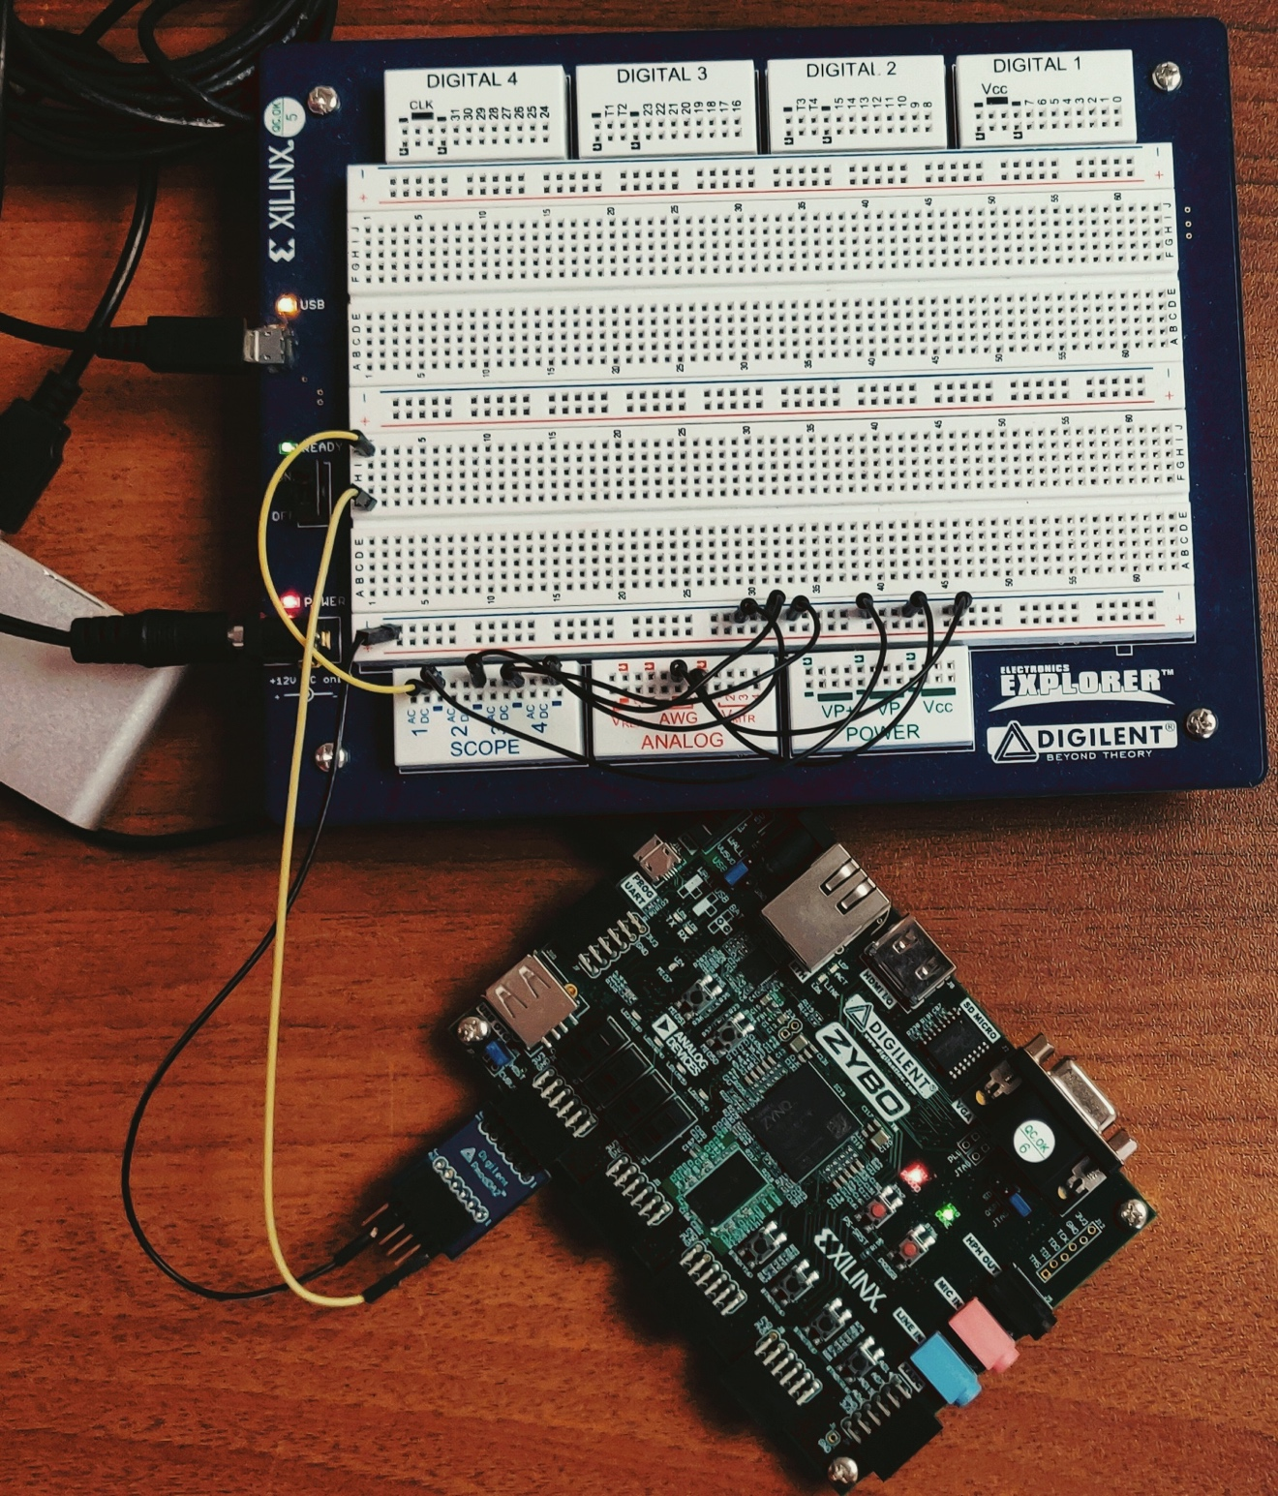Figure 1: Physical Setup
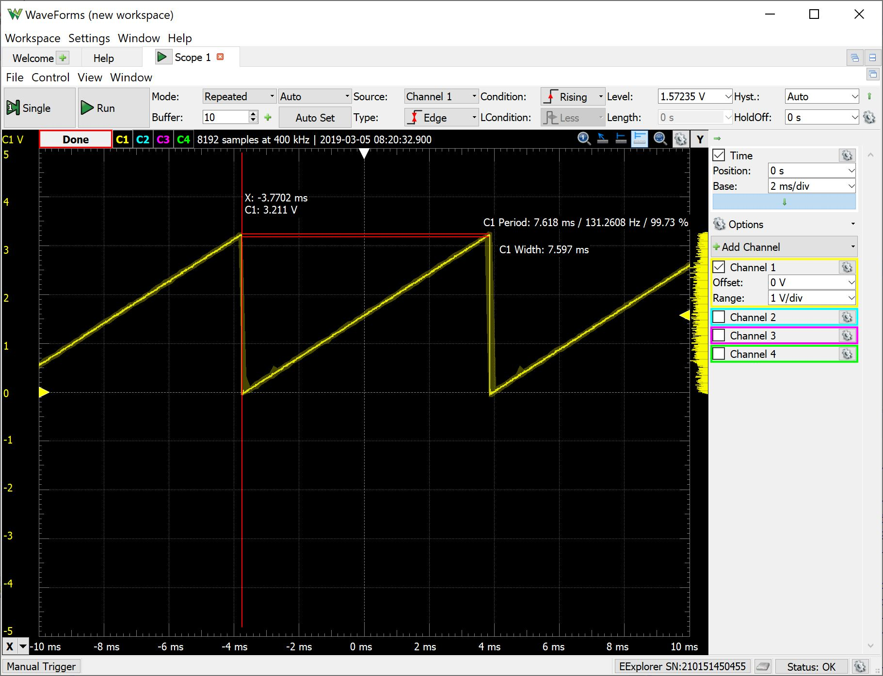Figure 2: Ramp
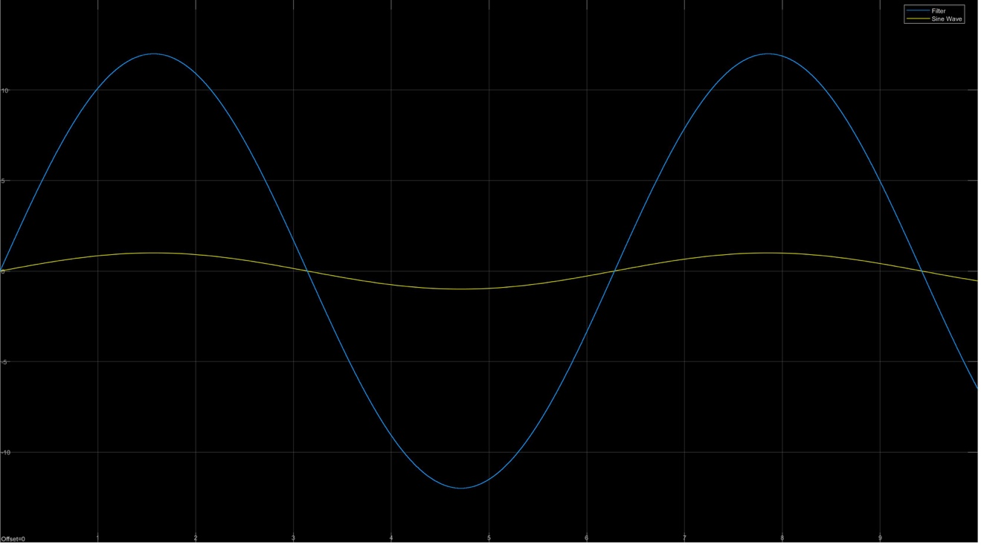Figure 3: Theoretical Sine and Filtered Sine

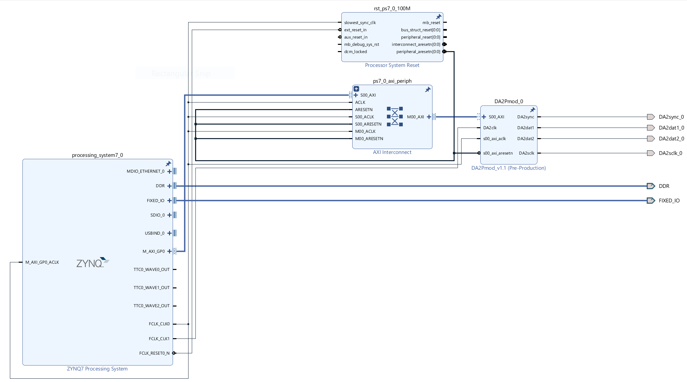Figure 4: Block Design
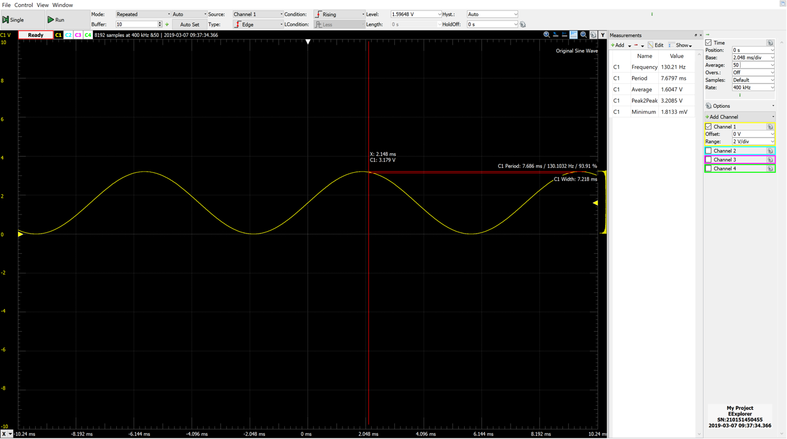Figure 5: n=1
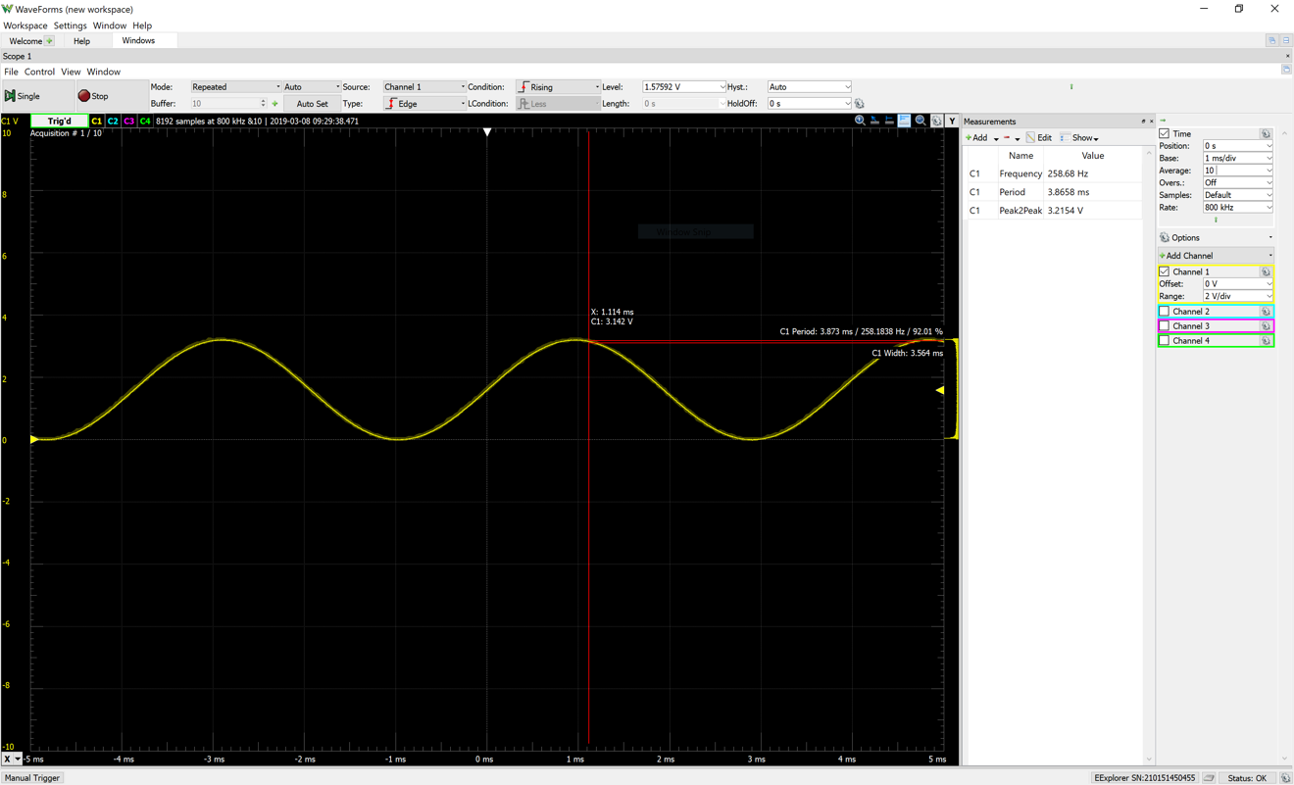Figure 6: n=2
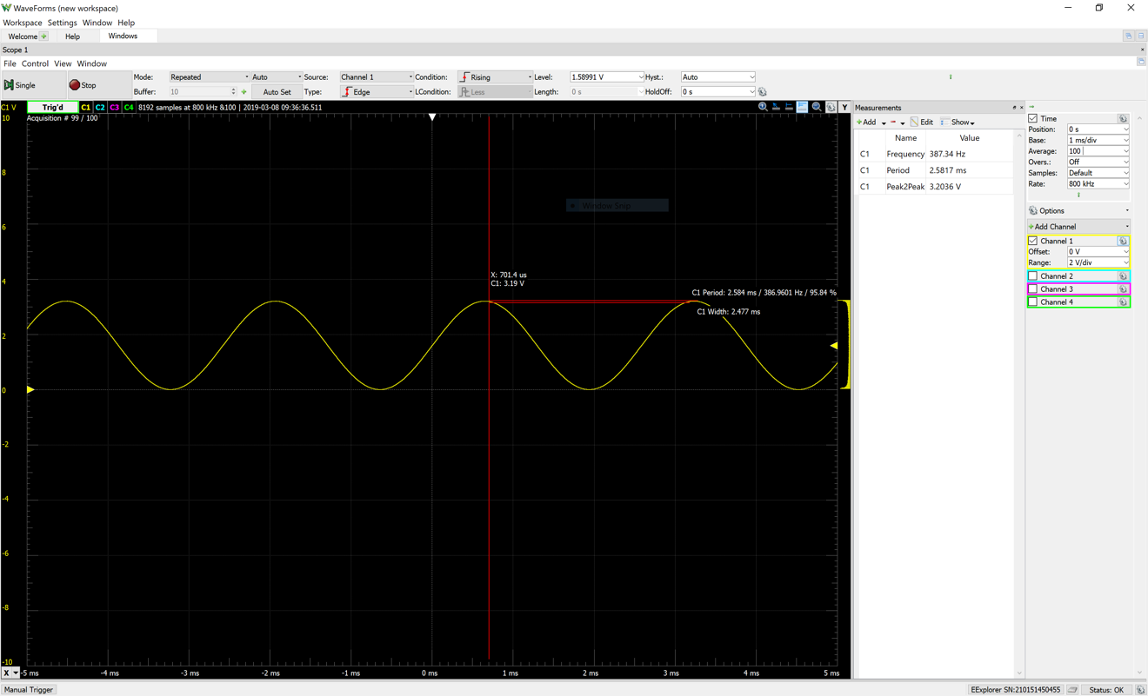Figure 7: n=3
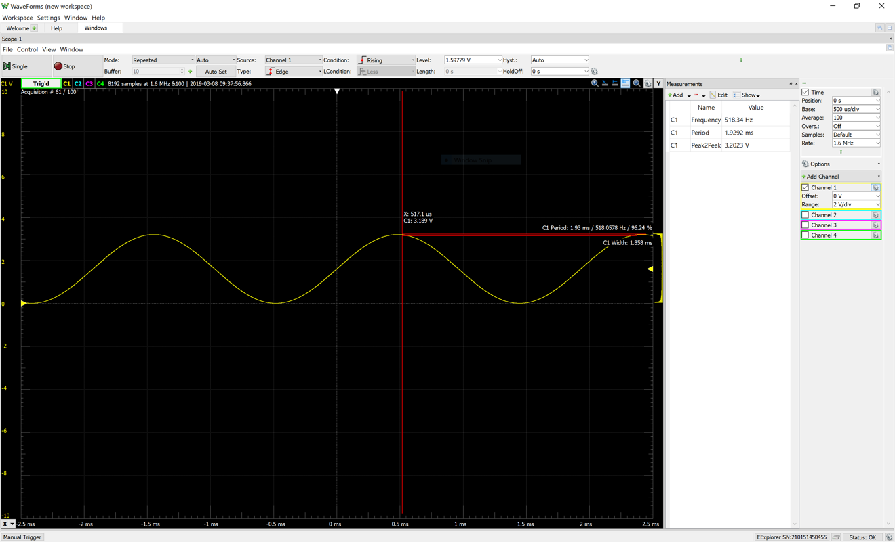Figure 8: n=4
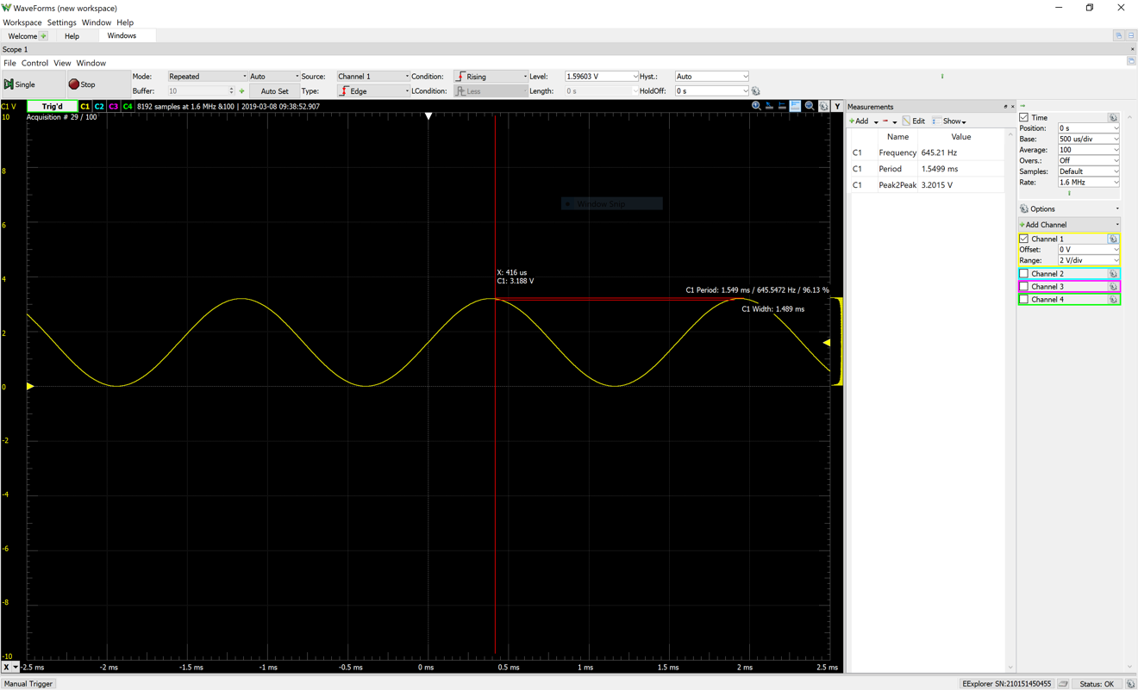Figure 9: n=5
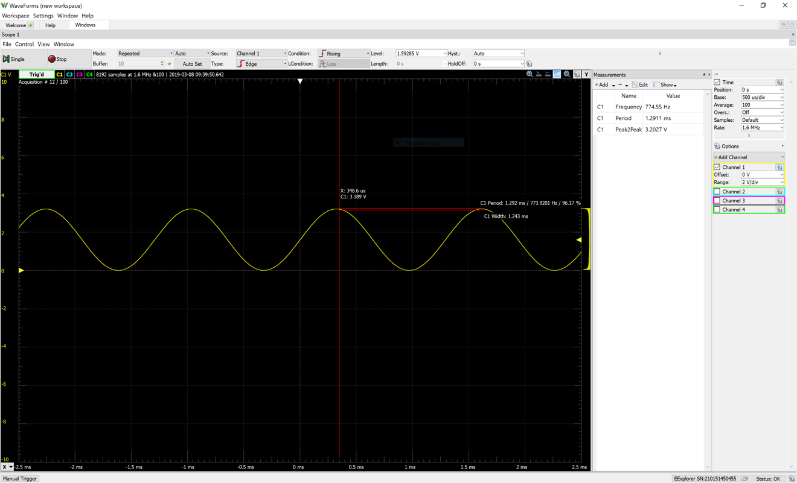Figure 10: n=6
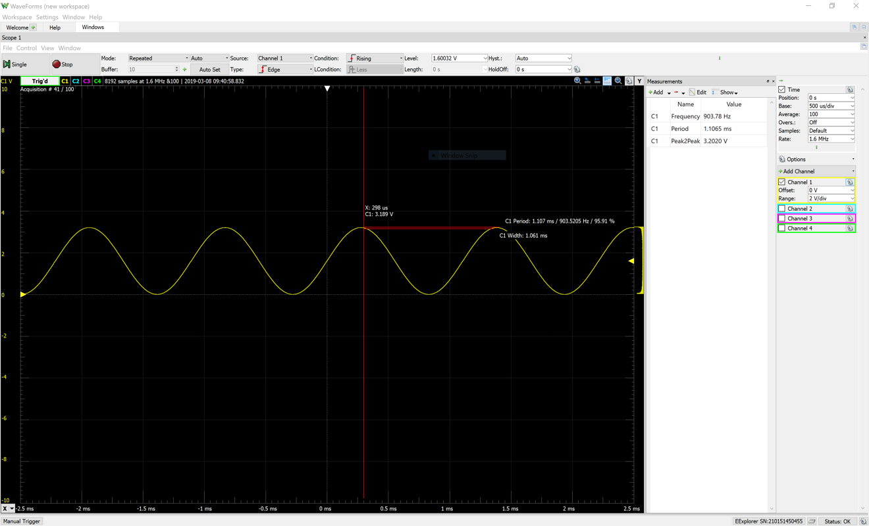Figure 11: n=7
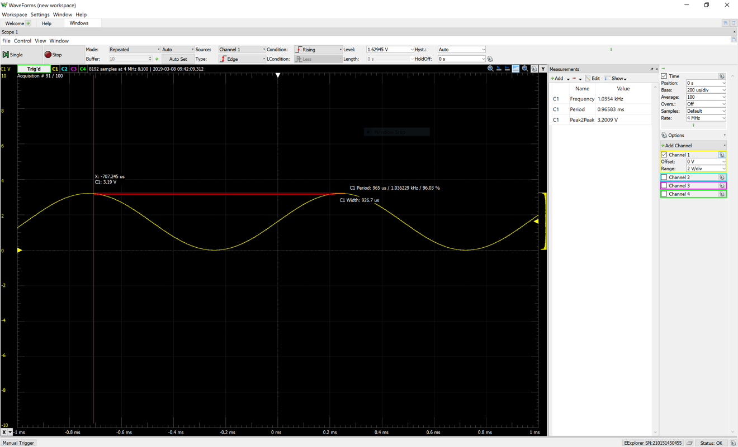Figure 12: n=8
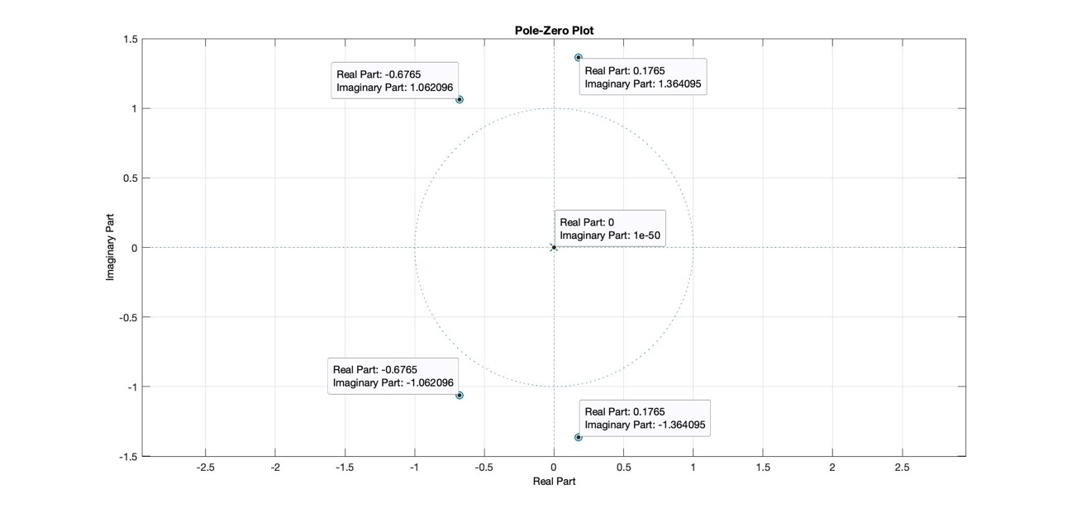Figure 13: Pole-Zero Plot
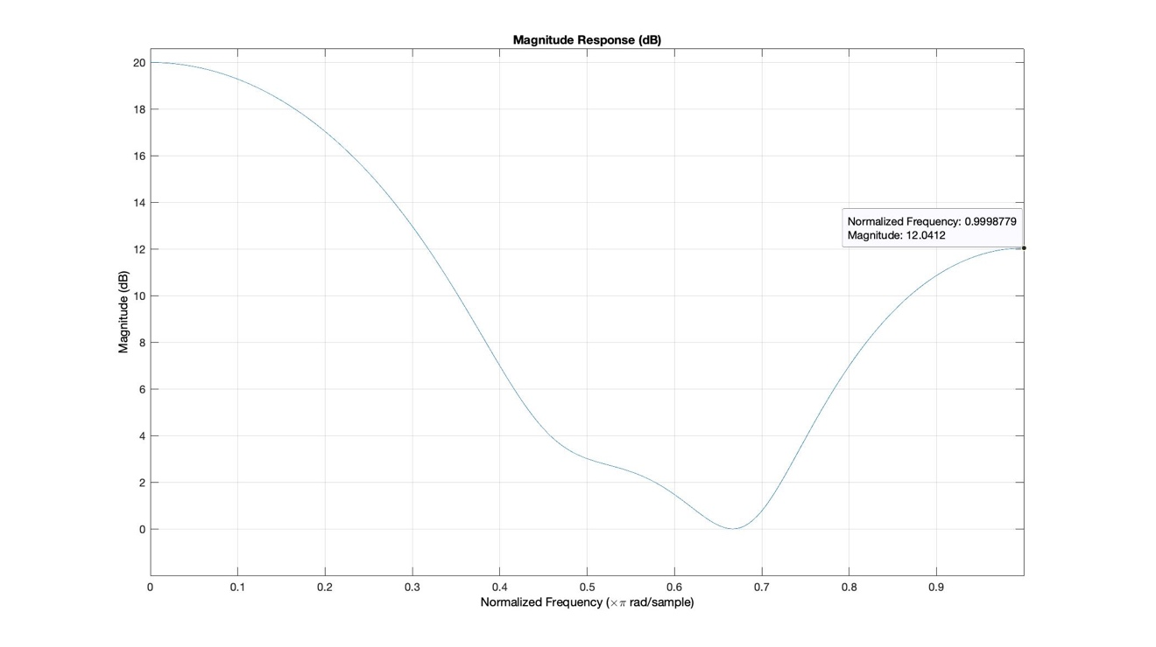Figure 14: Magnitude Response
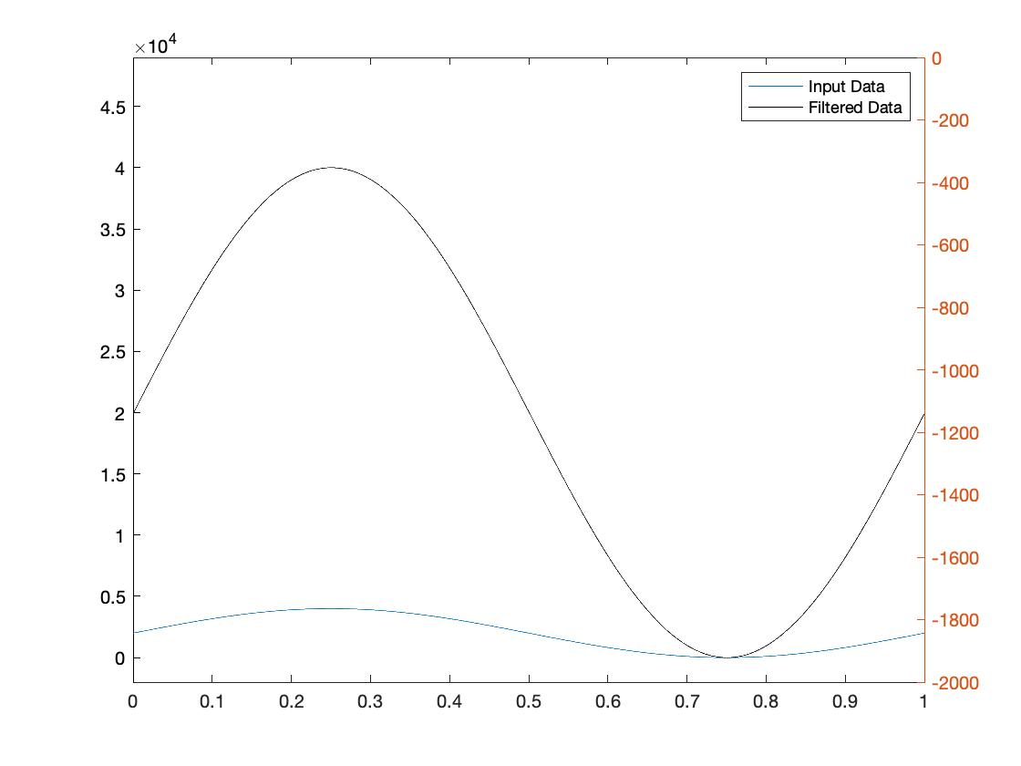Figure 15: Theoretical Stimulation
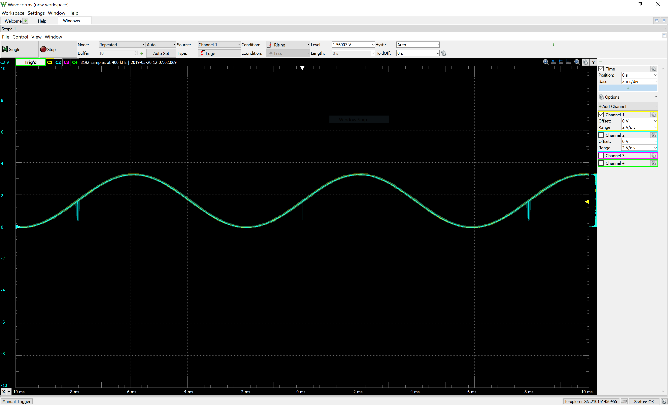Figure 16: Measured Sine and Filter Wave

